**Drive Your Way Web Application**

This document contains sections for:

* Sprint planning and Task completion
* Core concepts used in project
* Demonstrating the product capabilities, appearance, and user interactions.
* Unique Selling Points of the Application
* Conclusions

## Sprints planning and Task completion

The project is planned to be completed in 1 sprint. Tasks assumed to be completed in the sprint are:

* Creating the flow of the application
* Initializing git repository to track changes as development progresses.
* Writing the Java program to fulfill the requirements of the project.
* Testing the Java program with different kinds of User input
* Pushing code to GitHub.
* Creating this specification document highlighting application capabilities, appearance, and user interactions.

## Core concepts used in project

* Selenium Library
* Eclipse IDE
* TestNG Library
* Maven

## Demonstrating the product capabilities, appearance, and user interactions

To demonstrate the product capabilities, below are the sub-sections configured to highlight appearance and user interactions for the project:

1. Creating the project in Eclipse IDE.
2. Writing a code in java for the entry point of the application .
3. Create another class for Automation Purpose as “Test.java “.
4. First install TestNG Library in the project.
5. Add all the externals Jar library for Chrome Driver.
6. Now set chrome driver for getting access on the driver.
7. Run the code as TestNG.
8. Open test-output folder and see the test result after running index.html .
9. Pushing the code to GitHub repository

## **Step 1:** Creating a new project in VScode

* Open Eclipse
* Go to File -> New -> Other-> maven Project -> Next.
* Type in any project name and click on “Finish.”
* Select all the dependency at the project creation time.
* Select your project and go to Files.

**Step 2:** **Writing a c****ode for frontend.**

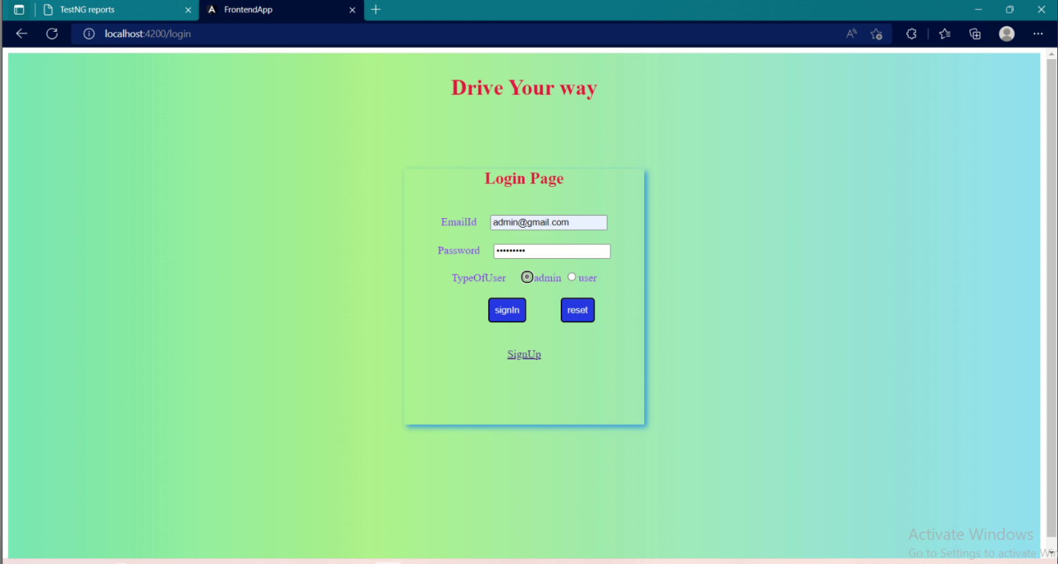

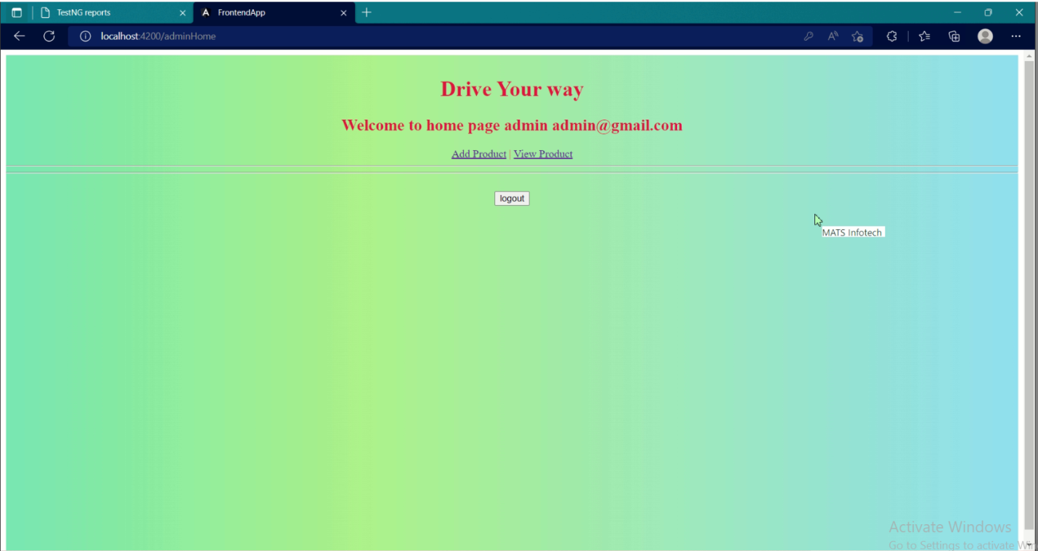

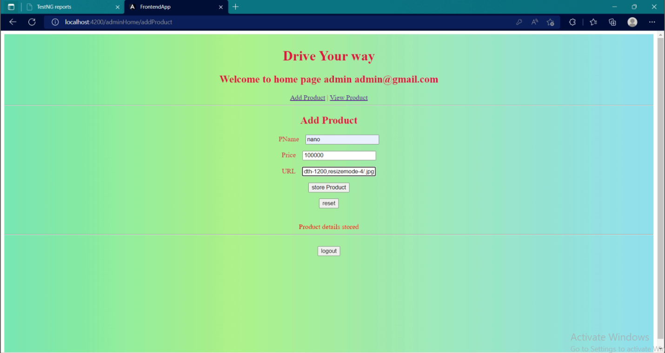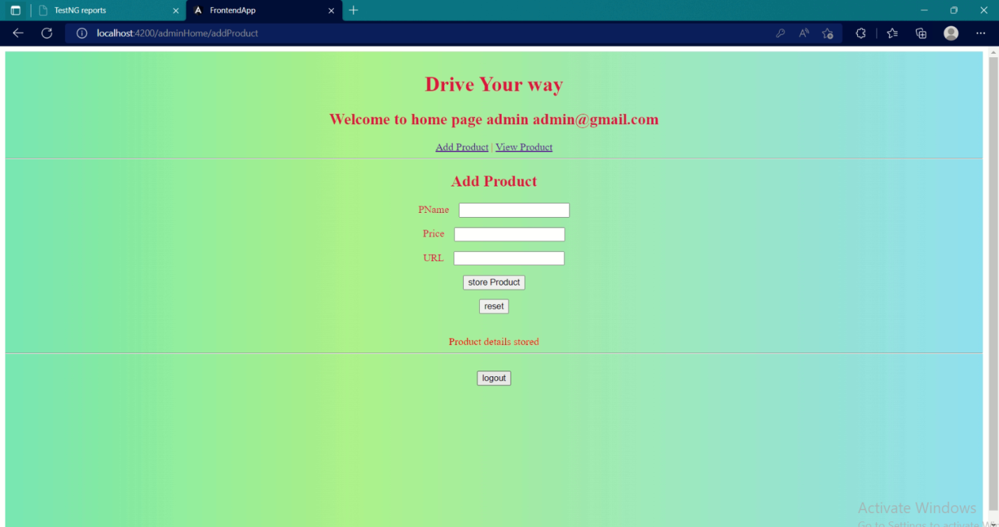

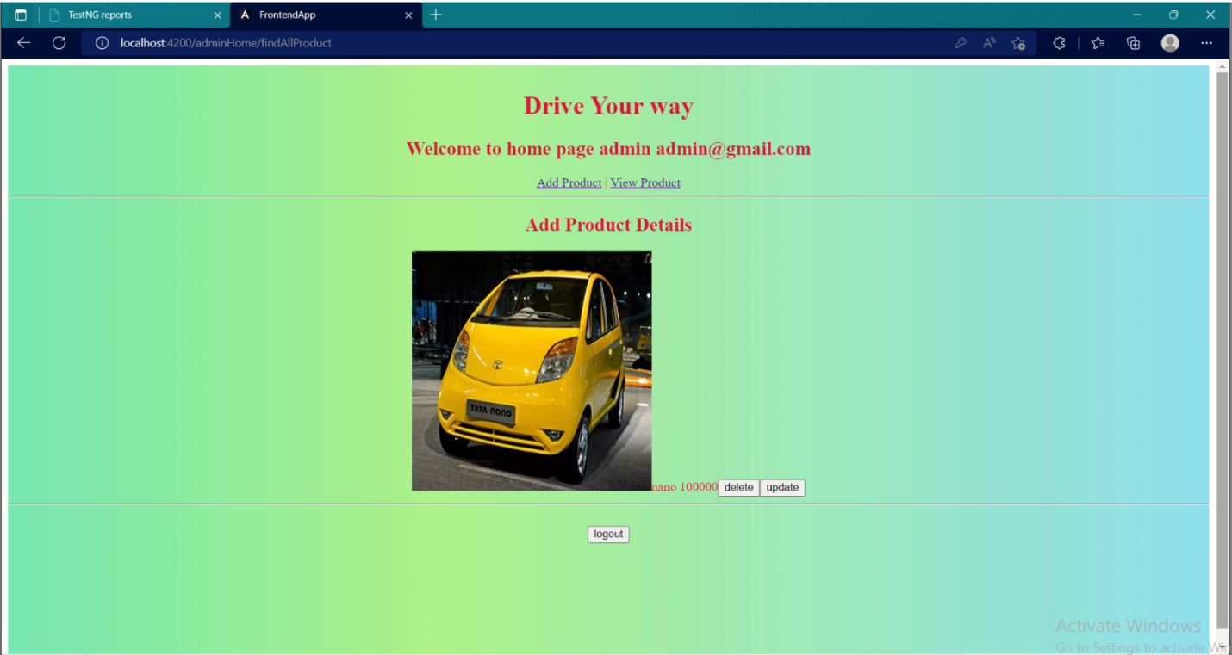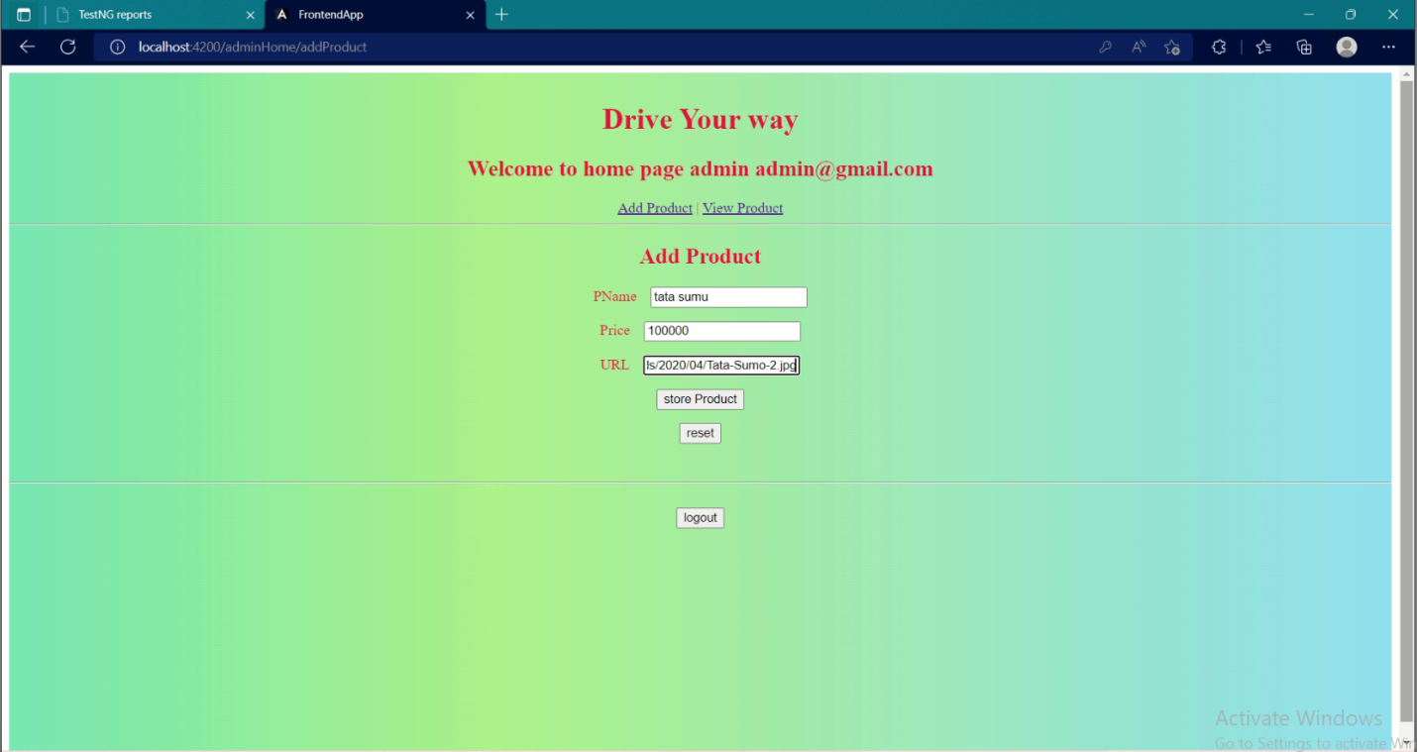

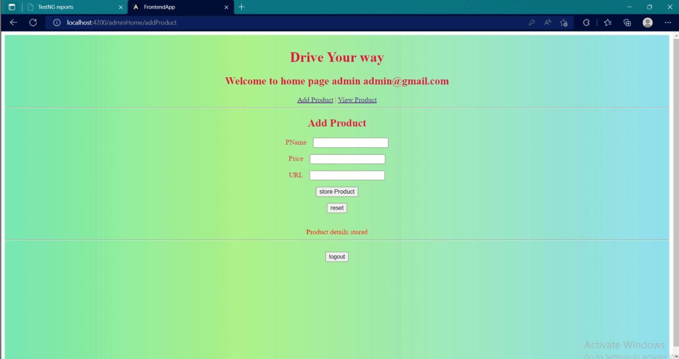

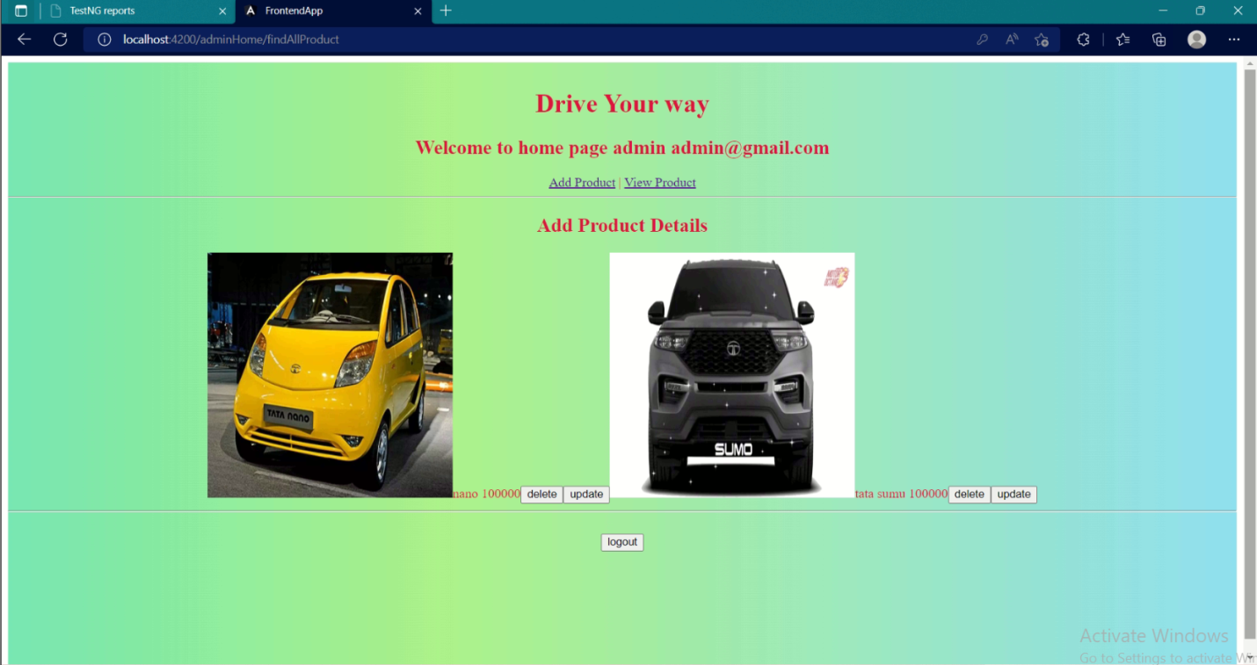

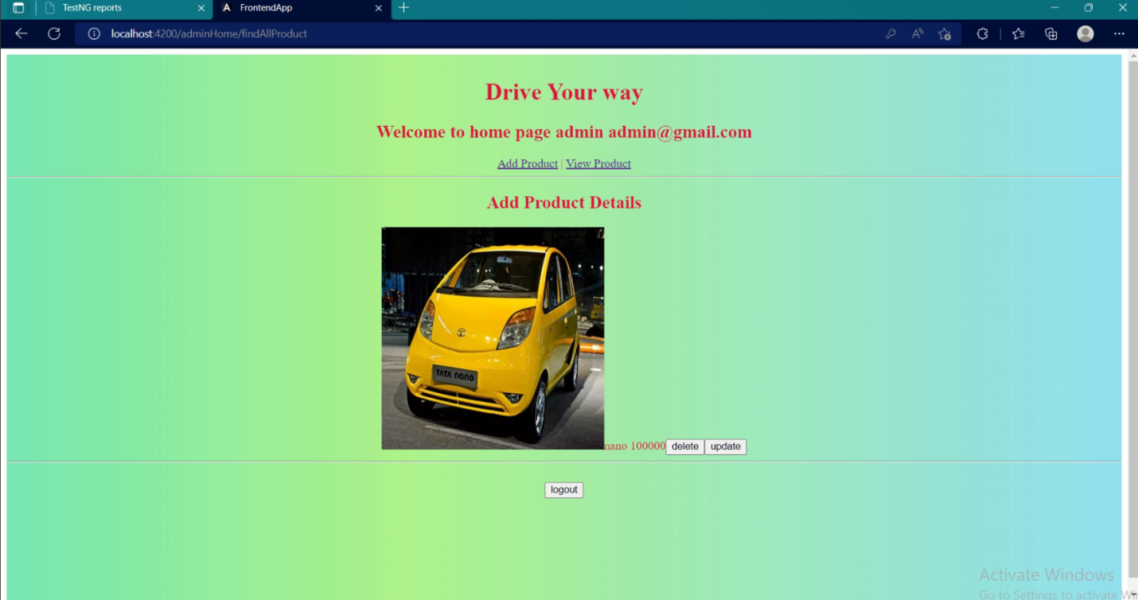

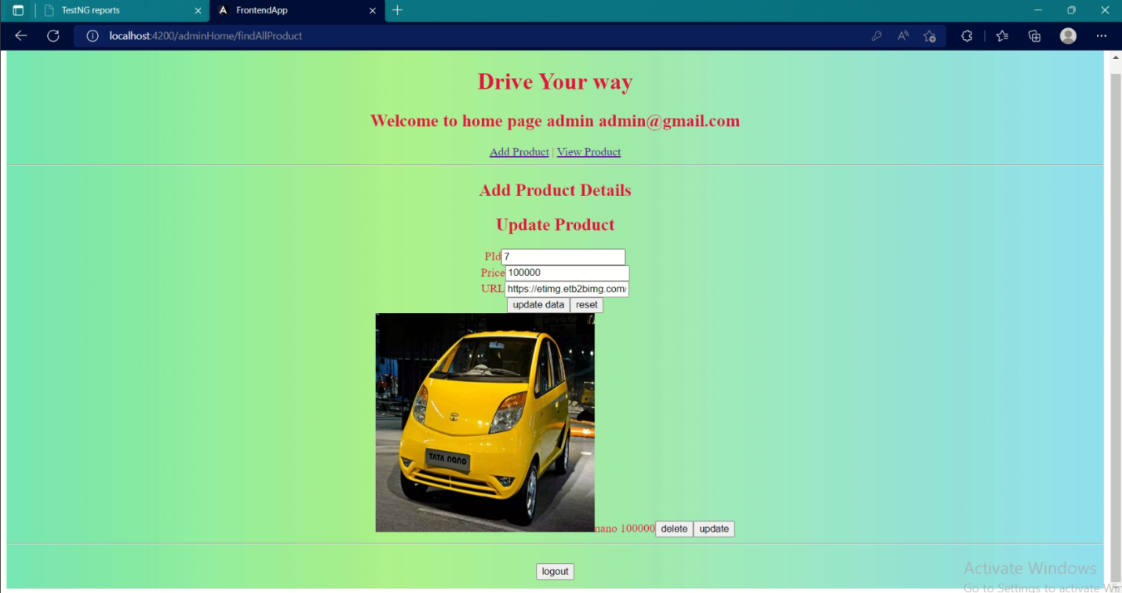

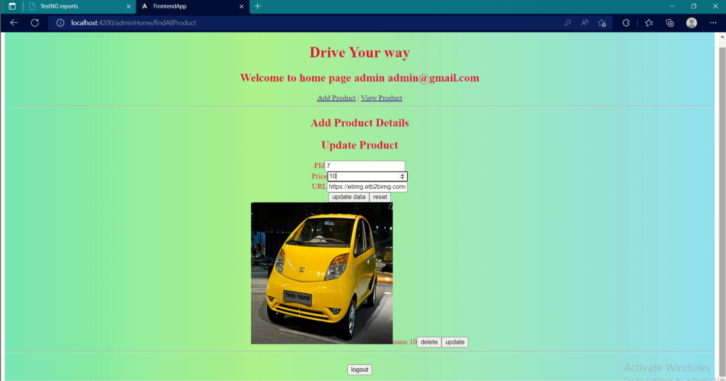

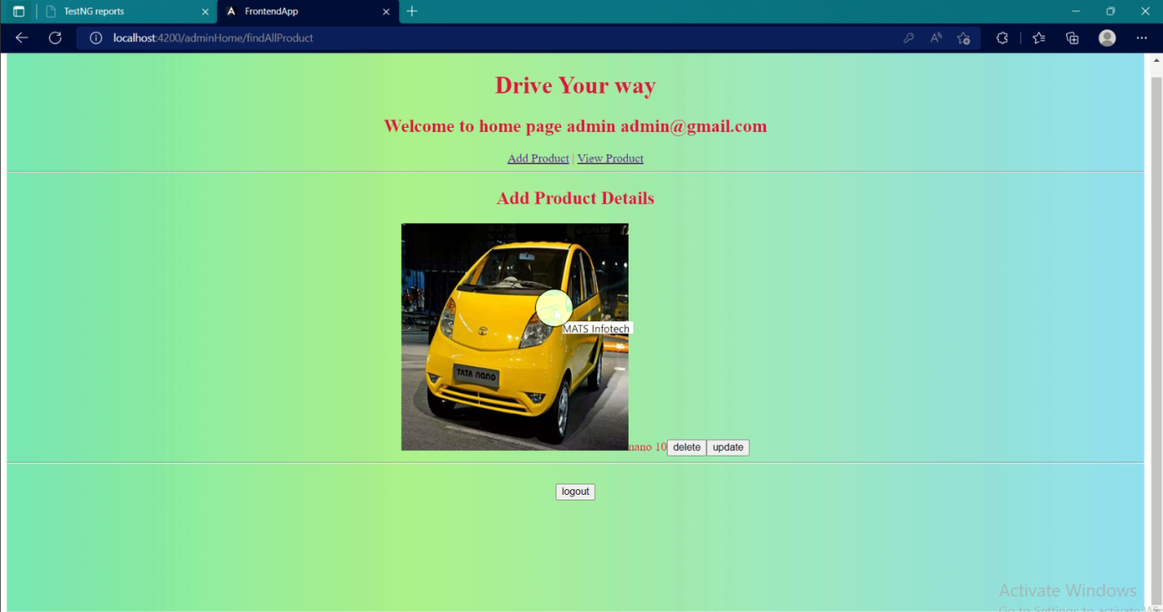

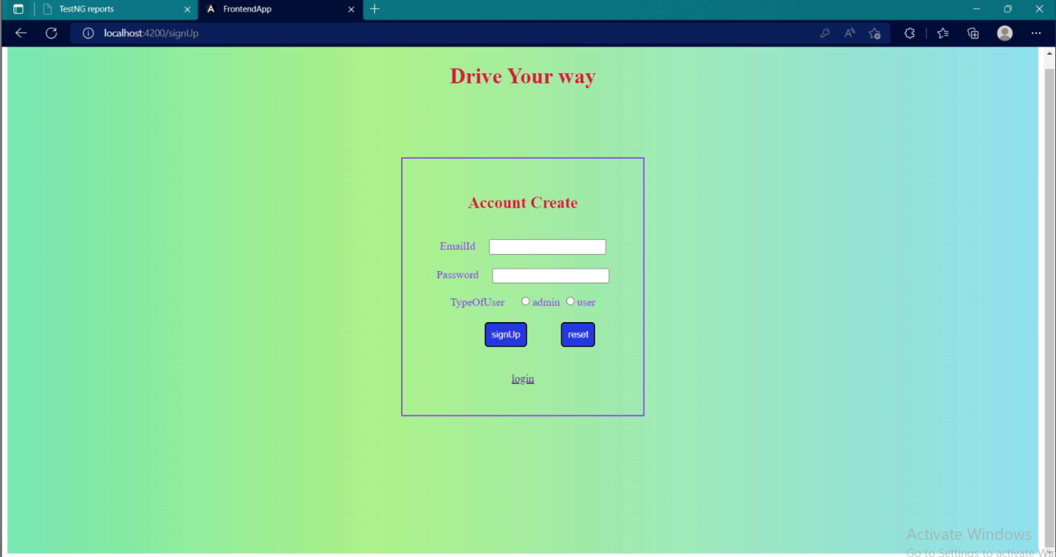

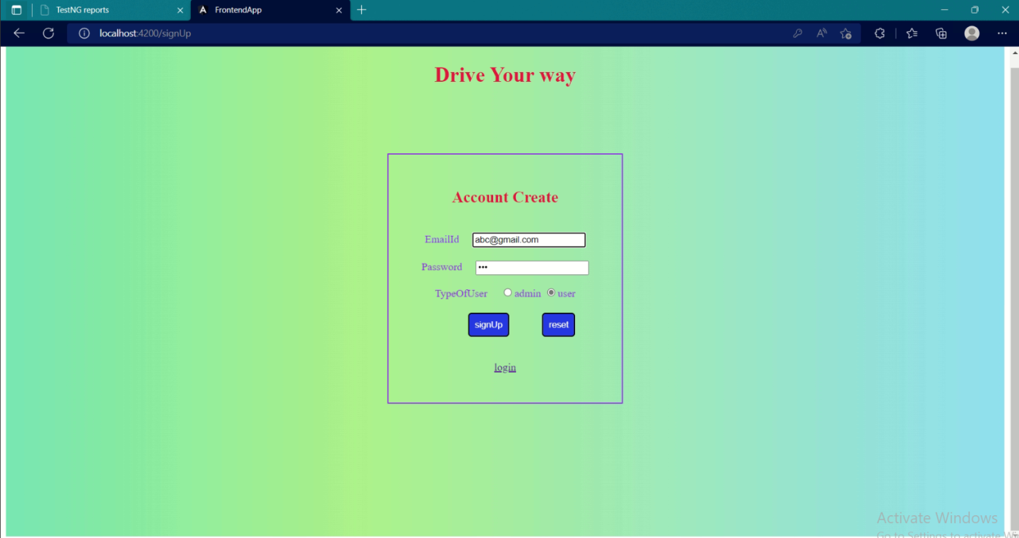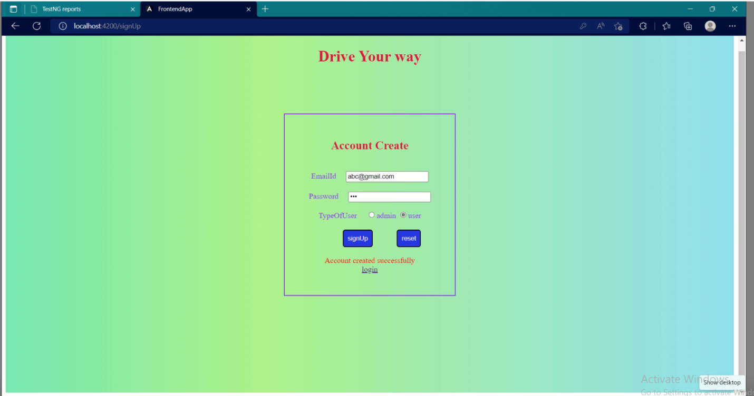

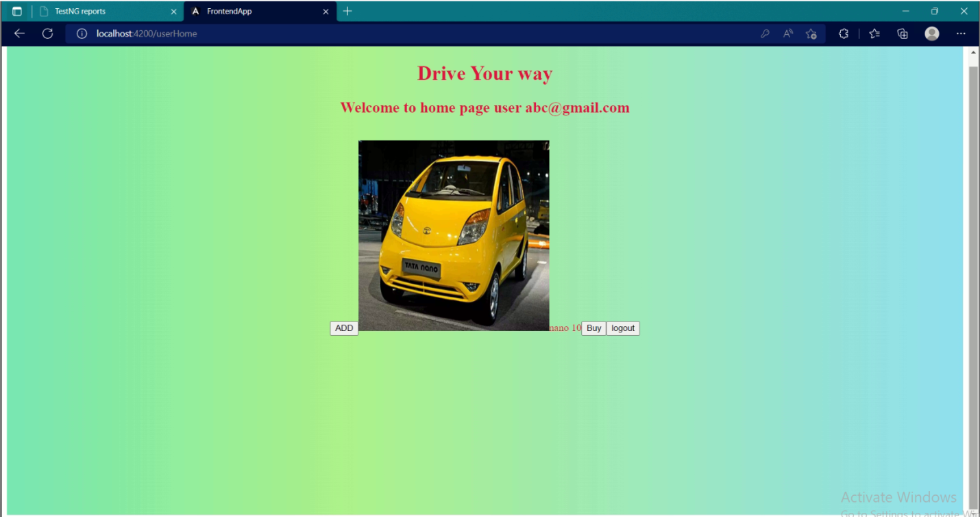

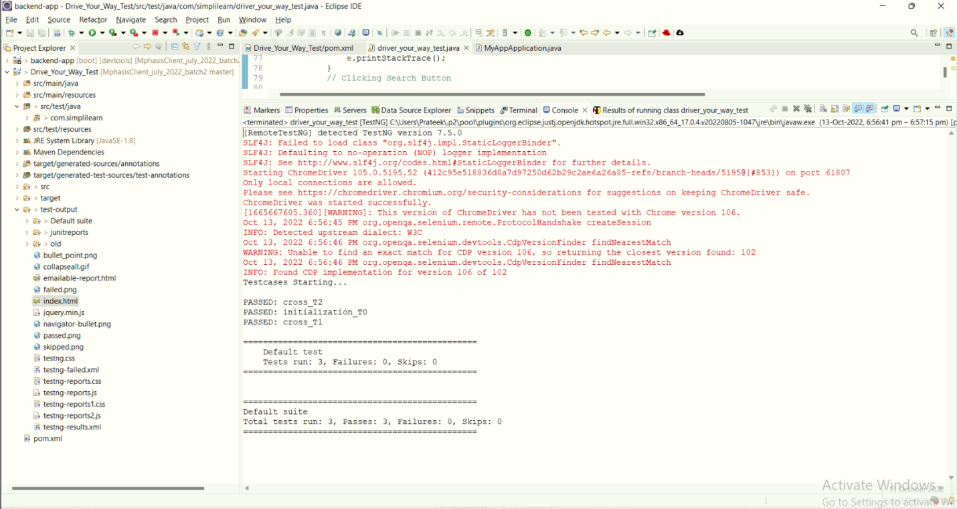

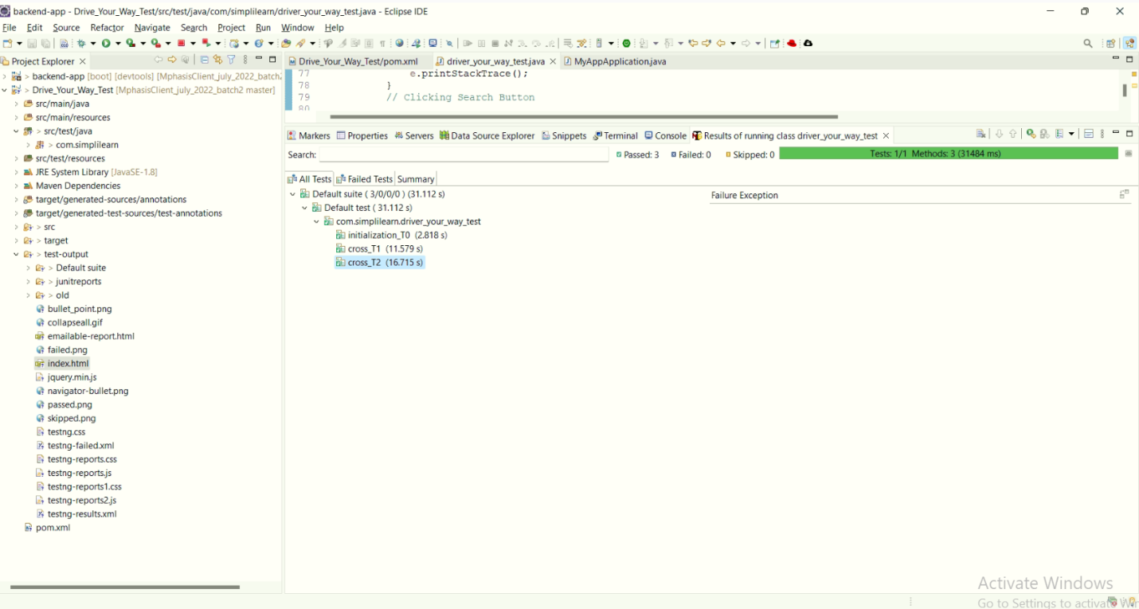

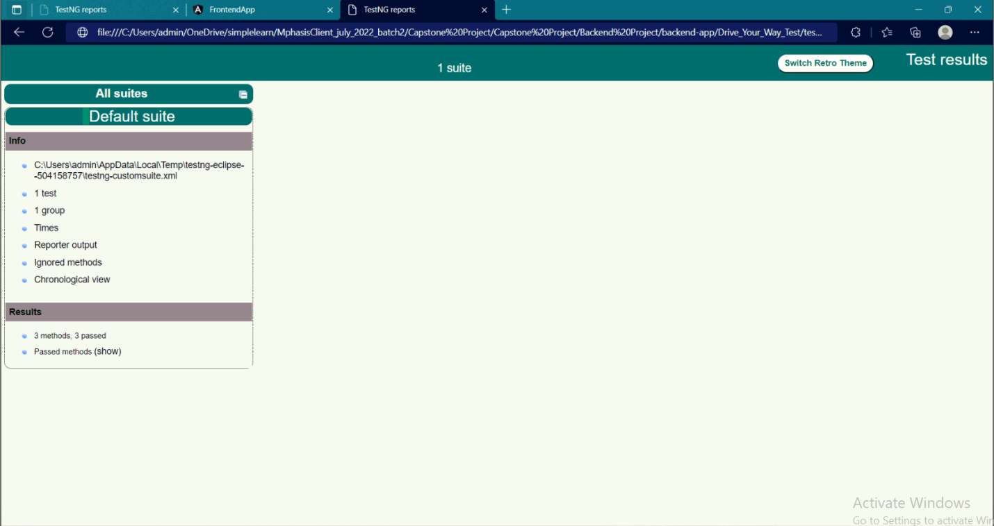

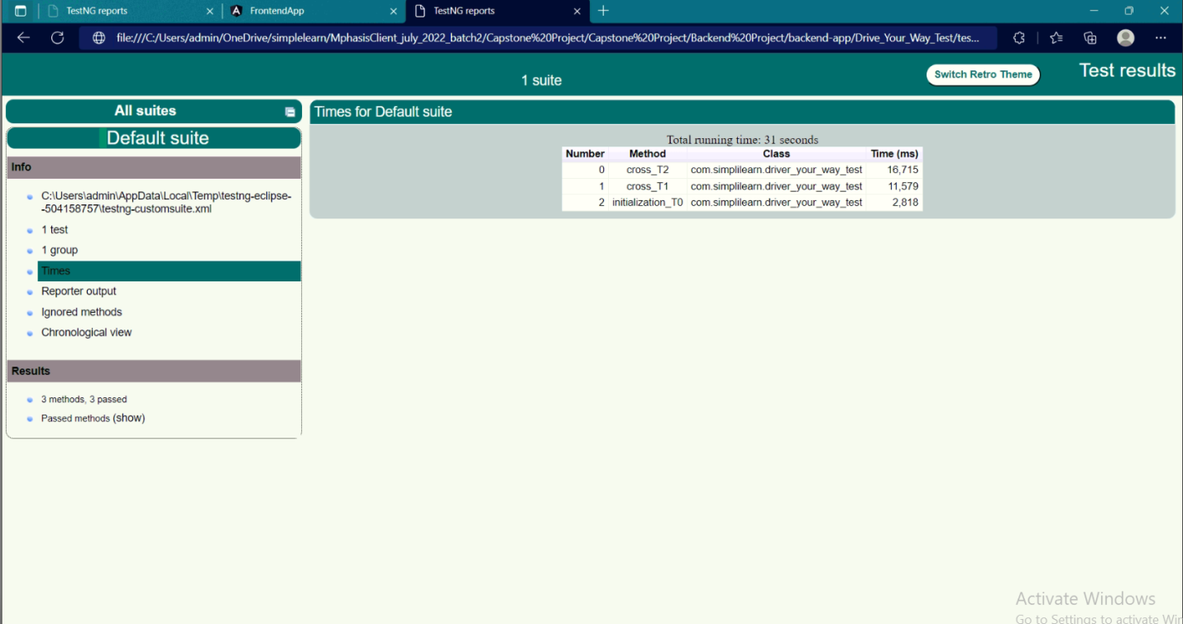

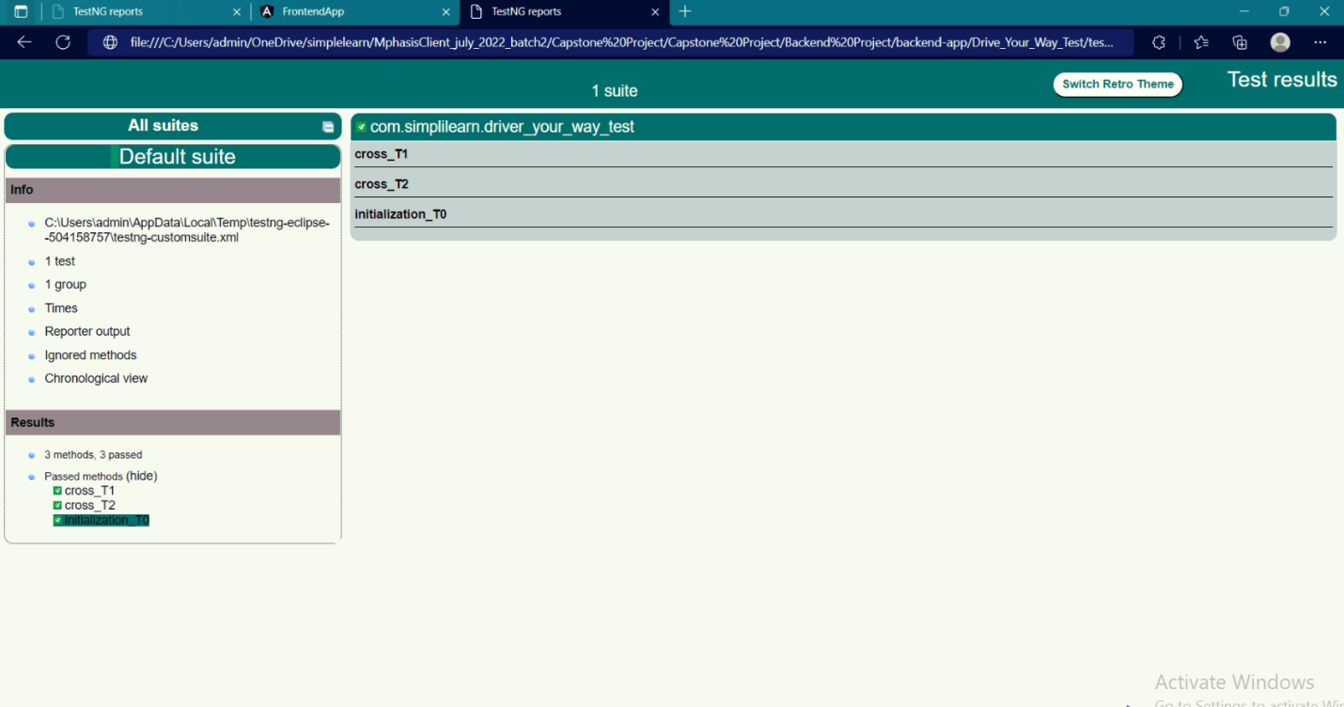

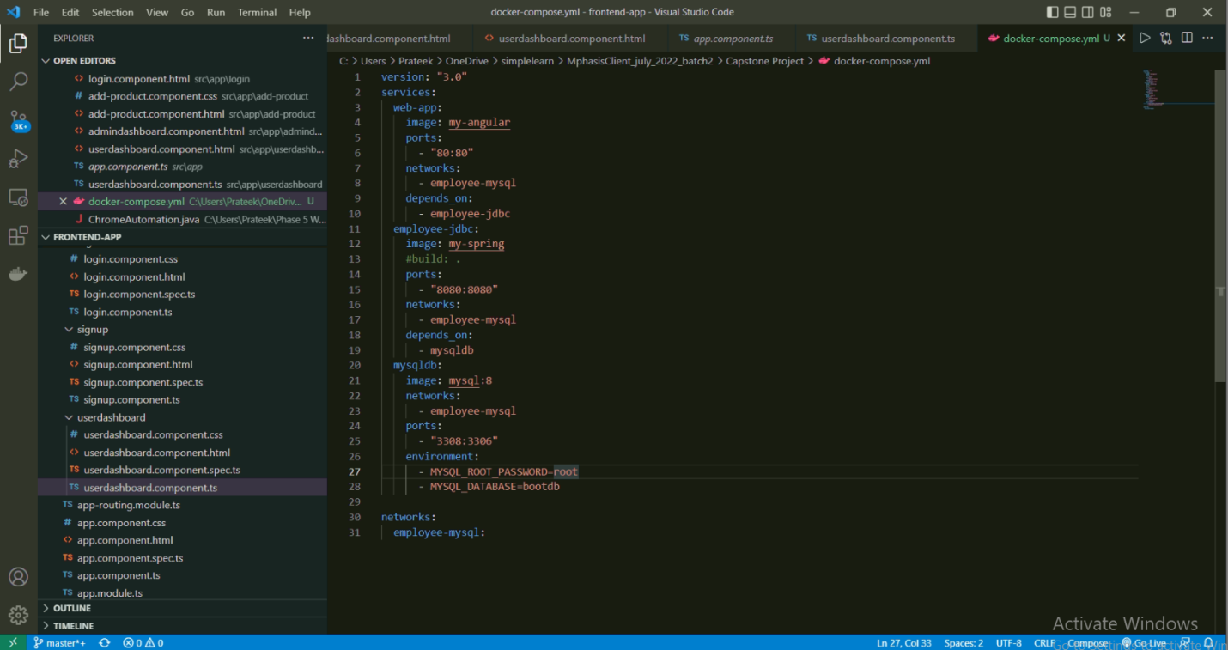

## **Step 10:** Pushing the code to GitHub repository

* Open your command prompt and navigate to the folder where you have created your files.

**cd <folder path>**

* Initialize repository using the following command:

**git init**

* Add all the files to your git repository using the following command:

**git add .**

* Commit the changes using the following command:

**git commit . -m <commit message>**

* Push the files to the folder you initially created using the following command:

**git push -u origin master**

## Unique Selling Points of the Application

1. The application is designed to E-Commerce Web Application
2. The application will generate complete test report after running.

## Conclusions

Further enhancements to the application can be made which may include:

* Address Producer-Consumer problem with multithreading. For example, if a user wants to book a car at the same time the listing is being deleted.
* A user can fill the form indicating interest for a particular car only once, to avoid duplication/spam.